

**AMERICAN INTERNATIONAL UNIVERSITY–BANGLADESH (AIUB)**

**FACULTY OF SCIENCE & TECHNOLOGY**

**DEPARTMENT OF PHYSICS**

**PHYSICS LAB 1**

**Summer 2020-2021**

**Section: J , Group: 1**

**LAB REPORT ON**

### **To determine the acceleration due to gravity applying linear least square regression method by using a simple pendulum.**

**Supervised By**

**BITHI PAUL**

**TABLE OF CONTENTS**

|  |  |
| --- | --- |
| **TOPICS** | ***Page no*.** |
| 1. **Title Page** | 1 |
| 1. **Table of Content** | 2 |
| 1. **Theory** | 3-4 |
| 1. **Apparatus** | 4 |
| 1. **Procedure** | 5 |
| 1. **Experimental Data** | 6 |
| 1. **Analysis and Calculation** | 7-9 |
| 1. **Result** | 9 |
| 1. **Discussion** | 10 |
| 1. **References** | 10 |
|  |  |

**Experiment Name: To determine the acceleration due to gravity applying linear least square regression method by using a simple pendulum.**

1. **Theory**

The time period of small-angle oscillation of a simple pendulum (a metal bob hanging vertically by a light string) may be proven to be



$T^{2}=(\frac{4Π^{2}}{g})L$

y = mx + c

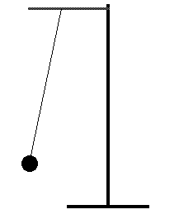 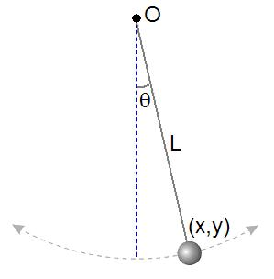

**Fig: 2**

**Fig: 1**

**Fig: simple pendulum**

where L is the length of the pendulum- the length from point of suspension to the center of the bob, g the acceleration due to gravity and slope, m = (4π2)/g.

### **Regression method:**

Considering x → the independent variable

y → dependent variable

N → number of data points.

,



The formula for determining the slope of the regression line

$$m=\frac{\sum_{i}{x_{i}y_{i}}-\frac{\left(\sum_{i}{x_{i}}\right)\left(\sum_{i}{y_{i}}\right)}{N}}{\sum_{i}{{x_{i}}^{2}-}\frac{{\left(\sum_{i}{x_{i}}\right)}^{2}}{N}}$$

Best fit line y = m x + c and intercept, c = y - mx

1. **Apparatus**

* Metal bob
* String
* Stand
* Clamp
* Meter scale
* Vernier caliper
* Electronic timer or a stop watch.

1. **Procedure**

• First of all, we need to connect a light piece of string with the hook of the metal bob and then we have to find the length L of the pendulum with a meter scale from the point of suspension to the mid-point of the bob.

•Now we need to give a small angle (less than 10 degrees) swing to the pendulum. Find the time period, T. To do it, measures the total time for 20 oscillations and divide it by 20 and repeat the procedure for different lengths and record the data in table.

•Using the Linear Least square Regression Method (LLSRM) to find the regression line and from the value of slope find g from the relation: slope = 4π2/g.

•At last we need to plot the same graph in Excel and find the value of g from the equation of the graph

1. **Experimental Data**

Table 1.1: Time periods T for different lengths L of the simple pendulum.

|  |  |  |  |  |  |  |
| --- | --- | --- | --- | --- | --- | --- |
| No. of Obs. | Effective Length  L  (cm) | Time for 20 Oscillations t  (s) | Time period  T = t/20 (s) | T2 (s2) | L2  (cm2) | L.T2  (cm.s2 ) |
| 1 | 150 | 48.94 | 2.447 | 5.988 | 22500 | 898.5 |
| 2 | 140 | 46.68 | 2.334 | 5.448 | 19600 | 761.6 |
| 3 | 130 | 45.38 | 2.269 | 5.148 | 16900 | 668.2 |
| 4 | 120 | 43.90 | 2.195 | 4.818 | 14400 | 69264 |
| 5 | 110 | 42.60 | 2.13 | 4.537 | 12100 | 577.2 |
| 6 | 100 | 39.59 | 1.979 | 3.918 | 10000 | 388 |
| 7 | 90 | 38.12 | 1.906 | 3.633 | 8100 | 326.7 |
|  | $\sum_{i}{x_{i}}$ = 840 |  |  | $\sum_{i}{y_{i}}$ =33.49 | =103600 | $$\sum_{i}{x_{i}y_{i=4126.16}}$$ |

1. **Analysis and Calculation**
2. **The value of g using the LLSRM:**

**m**= $\frac{\sum_{i}{x_{i}y_{i}- \frac{\left(\sum_{i}{x_{i}}\right) \left(\sum_{i}{y_{i}}\right)}{N}}}{\sum_{i}{x_{i}^{2}}-\frac{{\left(\sum_{i}{x_{i}}\right)}^{2}}{N}}=$ $\frac{4126.16-\frac{840*33.49}{7}}{103600-\frac{{(840)}^{2}}{7}}=0.038$

$\overline{x}= \frac{\sum_{i}{x_{i}}}{N}$ = $\frac{840}{7}$ = 120

$\overline{y }$ = $\frac{\sum_{i}{y_{i}}}{N}$ = $\frac{33.49}{7}=4.78$

Intercept, c = $\overline{y}$-m $\overline{x}$ = 4.78-0.038 * 120 = 0.22

Acceleration due to gravity by LLSRM, $g_{L}$ = $\frac{4π^{2}}{m}$ = $\frac{4{ * 3.1416}^{2}}{0.038}=1038.91$ $cm/s^{-2}$

= 10.38 m $s^{-2}$

**B. The value of g from the graph of Excel:**

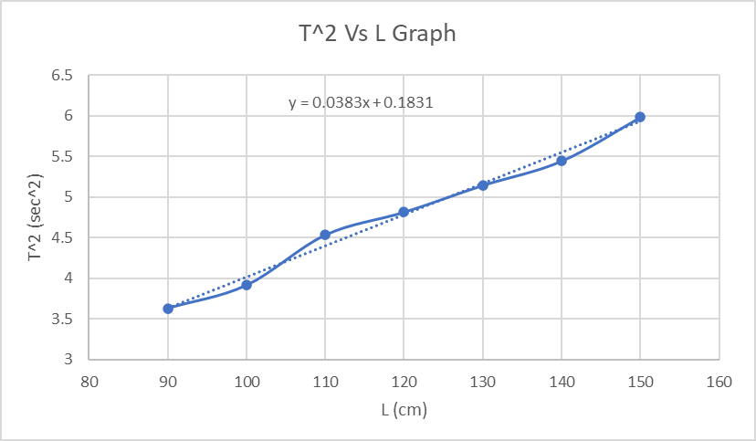

Slope of the regression line, m = 0.0383 x

Acceleration due to gravity by Excel, $g_{E}$ = $\frac{4π^{2}}{m}$ = $\frac{4{ *(3.1416)}^{2}}{0.0383}$ = 1030.77 $cm/s^{-2}$

= 10.30 m $s^{-2}$

# C. % difference in g:

Error of g = $\frac{ gth -gex}{gth}×100$% = $\frac{ 10.38 -10.30}{10.38}×100$% = 0.77 %

1. **Result**

|  |  |  |
| --- | --- | --- |
| **Method** | **Value of g(m/ $x^{2}$)** | **Comment** |
| **LLSRM** | 10.38 | The calculated gravitational acceleration from LLSRM is  10.38 m $s^{-2}$ and from graph the calculated gravitational acceleration is  10.30 m $s^{-2}$ and the percentage of error is 0.77 %. |
| **Excel** | 10.30 |

**7.Discussion**

* While measuring the oscillation of the bob there might be some error because the bob wasn’t moving freely because of some frictional problem.
* There might be some instrumental error in slide calipers so that there were some difficulties while measuring the bob.
* There might be some error while measuring the thread.
* The string stand was not properly straight.
* We might achieve the exact value by using wire instead of using the rope.

1. **References**

* Lecture slide
* Lab manual